**-:ASSESSMENT OF MODULE-4:-**

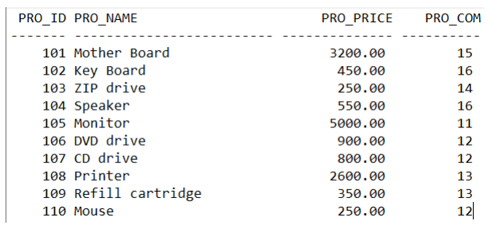

TABLE:-

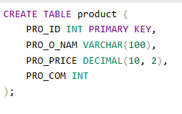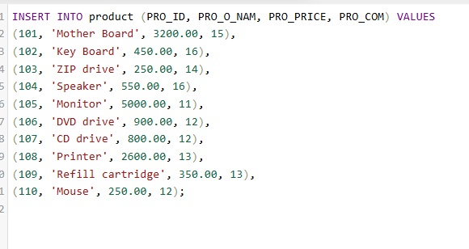

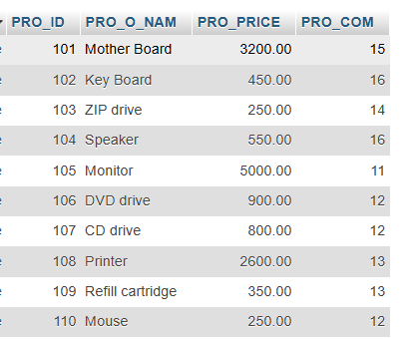

QUESTIONS:_

● Write sql query to find the items whose prices are higher than or equal 250rs. Order the result by product price in descending, then product name in ascending. Return pro_name and pro_price

ANS:-

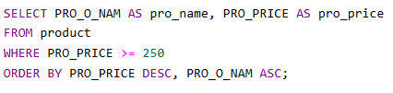

OUTPUT:-

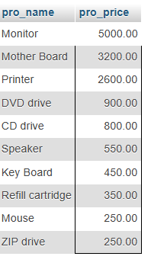

● Write a sql query to find the cheapest item. Return pro_name and pro_price.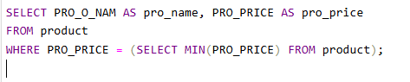

OUTPUT:-

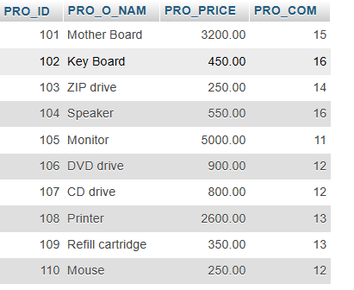

● Write the sql query to calculate the average price of the items for each company. Return average price and company code.

ANS:-

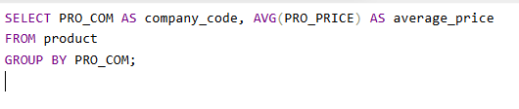

OUTPUT:-

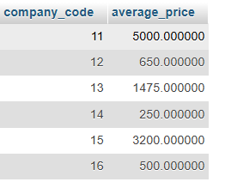

● Write the sql query to find the average total for all the product mention in the table

ANS:-



OUTPUT:-

